Business Requirement Document (BRD)
For
Support for Emerging Export Opportunities (SEOE) Scheme

Document Title | New Scheme Development – Support for Emerging Export Opportunities (SEOE) Scheme
Version | 1.0
Date | 28th April 2026
Prepared By (Infoneo) | Pinkey (BA)

1. Introduction
The objective of this document is to define the business requirements for implementing the SEOE Scheme on the SURGE platform, in collaboration with EXIM Bank as the primary operational partner.
The API integration facilitates secure and structured data exchange between NCGTC and EXIM bank to enable automated loan information processing and validation.
- EXIM Bank will:
  - Manage onboarding and interaction with MLIs (Member Lending Institutions)
  - Push transaction-level data to NCGTC
- This integration aims to:
- Enable automated guarantee processing
- Ensure secure API-based communication
- Provide real-time validations
- Automate CG Fee calculation and invoice generation

2. Scope & System Overview
- The system will be fully API-driven with integration from EXIM Bank.
- New Credit Guarantee (New CG) processing.
- Update Credit Guarantee (Update CG) processing.
- CG Fee calculation logic.
- Exposure limit validation.
- Invoice generation via API.
- Refund and fee collection mechanism

2.1 Fund and Docket Construct
Currently it is being envisaged that this scheme has one docket. These docket have code - ‘GEN’. Schematic relation for the Trust, Fund, Scheme and Docket Relation is as below:
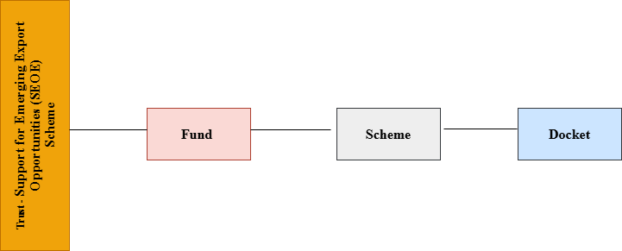

2.1 System Overview
The system will function as a centralized API-driven platform, where:
- EXIM Bank submits guarantee data via APIs
- SURGE system validates and processes the data
- CG Fee is calculated automatically
- Invoice is generated and shared via API

EXIM Bank – SURGE System API Integration Data Flow:-
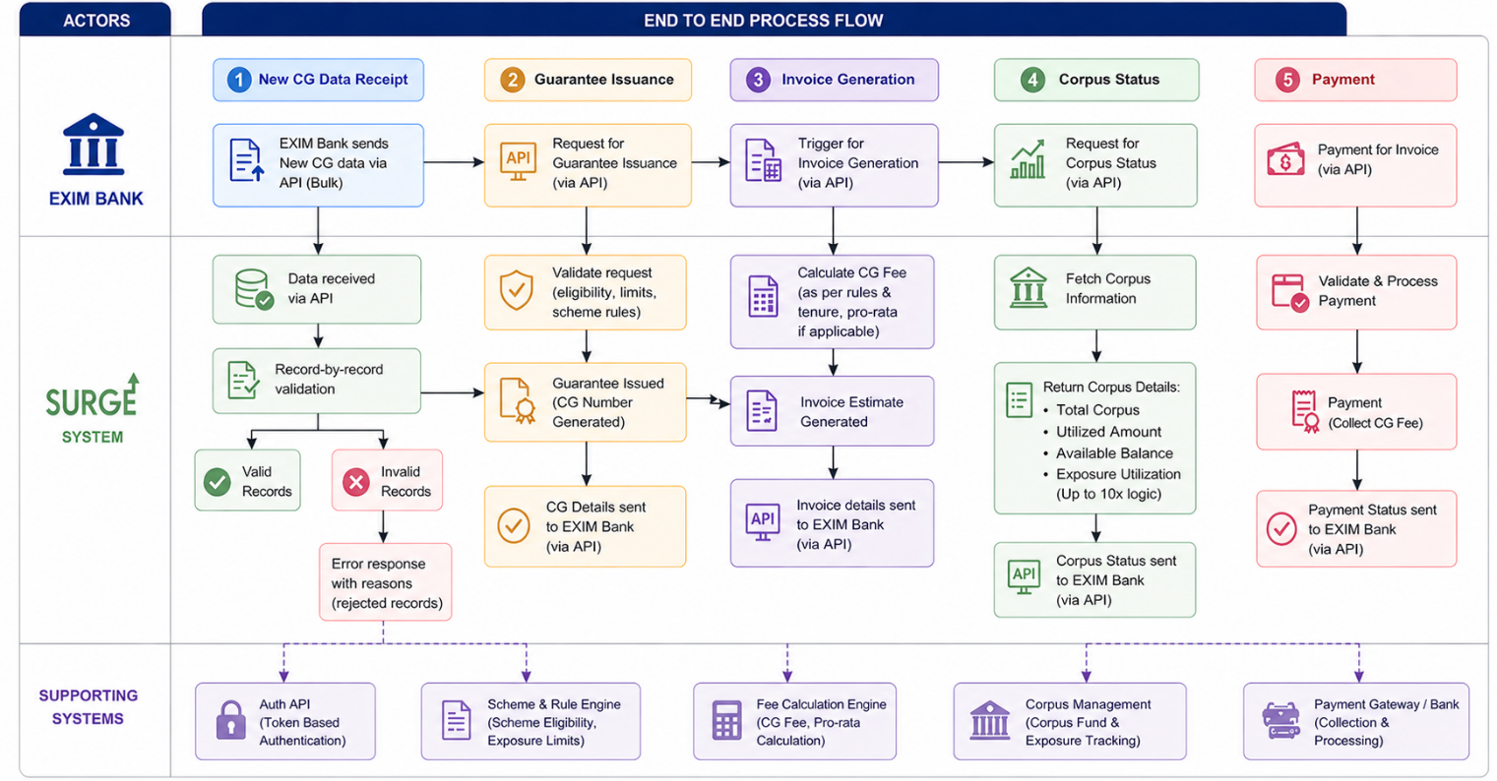

API Integrations Required:-
API Type | Description
New CG API | Receive fresh guarantee data from EXIM Bank
Update CG API | Receive updated loan details from EXIM Bank
Payment API for CG fee | To receive CG fee from EXIM Bank
Corpus Status API | To sent Corpus details to EXIM Bank via API

3. Modules
3.1 New CG Module:-
EXIM Bank will sends bulk data via the New CG API and the system will processes it through record-by-record validation.
Below are the fields mentioned:-
Sr. No. | Field Name | Description | Type | Mandatory/Optional | Validations
1 | Name of Exporter/Beneficiary | Name of the entity | Alphanumeric | Mandatory
2 | Importer Exporter Code (IEC) | Exporter's (Importer Exporter Code) | 10-digit Alphanumeric | Mandatory
3 | Name of Importer/Applicant | Name of the entity | Alphanumeric | Mandatory
4 | Beneficiary Bank (Partner Bank) | Name of the beneficiary bank (Partner Bank) | Alphanumeric | Mandatory
5 | Document Type | Stand-by letters of credit (SBLC)/Risk Participation (RP)/Irrevocable Reimbursement Undertaking (IRU) | Dropdown | Mandatory
6 | Document Number | Identifying number of instrument (LC,RP, IRU) | Alphanumeric | Mandatory
7 | Udyam Registration Number (Unique field) | Udyam Registration Number of exporter | Alphanumeric | Mandatory
8 | Unique Identification Number (UIN)(Unique field) | UIN issued on DGFT portal to exporter | Alphanumeric | Mandatory
9 | Transaction ID | Transaction ID issued by EXIM Bank of exporter | Alphanumeric | Mandatory
10 | Transaction Date | Date of Transaction | Numeric | Mandatory | After date of issuance of guidelines
11 | Transaction Amount | Guarantee Amount by NCGTC | Amount in Rs. | Mandatory | 10 times of corpus fund + accrued interest excluding closed and expired guarantees (MLP validation)
12 | Risk Score | Enter the risk score for the borrower | Risk score to be entered | Mandatory | Guarantee coverage and % of fees charged p.a. will be decided on the basis of this
13 | Tenure of Guarantee Cover | Enter the tenure for which guarantee cover is required adding 5/10 days to lodge the date | Numeric | Mandatory
14 | Type of Exporter | Micro/Medium/Small Enterprise/EPC/Commodity Board/DEPC/SEPC/Gov | Dropdown | Mandatory
15 | Products/Services | Product/service the business is dealing in | List available in Surge Code | Mandatory
16 | Target Export Markets | Country the export business is targeting | List available in Surge Code | Mandatory
17 | Issuing Bank / Importer Bank | Lending Institution | List available in Surge Code | Mandatory
18 | Exposure Limit | Yes/No dropdown whether within respective MLP limits | Dropdown | Mandatory | If No is selected, then guarantee should not be issued
19 | PAN No. (Unique Field) | PAN number of the exporter's business | Alphanumeric | Mandatory | NPA marked PAN cannot avail guarantee cover
20 | Registered - Address Line | Exporter's registered address of business - Shop no. & Building | Alphanumeric | Mandatory
21 | Registered - City/Town/Village | Exporter's registered city/town/village of business | Alphanumeric | Mandatory
22 | Registered District | Exporter's registered district of business | List available in Surge Code | Mandatory
23 | Registered - State | Exporter's registered state of business | List available in Surge Code | Mandatory
24 | Registered-Country | Exporter's registered country of business | List available in Surge Code | Mandatory
25 | Registered - Pin Code | Pin Code of place of business of Exporter's | Number (upto 6 digits) | Mandatory
26 | Mobile Number | Mobile no. of the exporter | Alphanumeric (upto 15 digits) | Mandatory
27 | Gender | Gender of the promoter of the exporter | List available in Surge Code | Mandatory
28 | Religion | Religion of the borrower of the exporter | List available in Surge Code | Mandatory
29 | Caste Category | Caste category of the borrower of the exporter | List available in Surge Code | Mandatory
30 | Risk Score-Guarantee Cover-Guarantee Fee Calculation | Score Range mentioned below. Classification to be done as per point 12 above and table given at the end. | Numeric | Display risk score, guarantee coverage and % of fees charged p.a.
31 | CG Fees | For Transaction amount and auto-calculated as per point 29 above | Amount in Rs. | Display
32 | CG Cover | Coverage in rupees | Amount in Rs. | Display

• For valid records:
- Guarantee created
- CG Fee calculated
- Invoice Estimate generated (will show due date of 3 days from date of Invoice generation – No penalty will be charged here for delayed payments).
• Response includes:
- Success records
- Failed records with error reasons
Validation for Exposure Limit:-
- Maximum exposure allowed will be up to 10 times of the available corpus fund.
To be Checked
Cap-wise | Exposure % of MLP
Country | 15%
Exporter | 5%
Transaction | 1%
Issuing bank | 10%

Example: -
Assume the following:-
- Available Corpus Fund = ₹1,000 Crore
- Maximum Exposure Allowed (10× Corpus) = ₹10,000 Crore
Below are the Defined Limits:-
Category | Limit % | Max Allowed Exposure
Per Transaction | 1% | ₹100 Crore
Per Exporter | 5% | ₹500 Crore
Per Country | 15% | ₹1,500 Crore
Per Issuing Bank | 10% | ₹1,000 Crore
Scenario: New Guarantee Requests follows:-
- Transaction Amount = ₹120 Crore
- Exporter Current Exposure = ₹450 Crore
- Country Current Exposure = ₹1,400 Crore
- Issuing Bank Exposure = ₹950 Crore
- Total System Exposure (before this transaction) = ₹9,800 Crore
Validation Checks:-
- Overall Corpus Limit Check
  - ₹9,800 Cr + ₹120 Cr = ₹9,920 Cr ≤ ₹10,000 Cr ✅ Pass
- Per Transaction Limit (1%)
  - Allowed = ₹100 Cr
  - Requested = ₹120 Cr ❌ Fail
- Per Exporter Limit (5%)
  - ₹450 Cr + ₹120 Cr = ₹570 Cr > ₹500 Cr ❌ Fail
- Per Country Limit (15%)
  - ₹1,400 Cr + ₹120 Cr = ₹1,520 Cr > ₹1,500 Cr ❌ Fail
- Issuing Bank Limit (10%)
  - ₹950 Cr + ₹120 Cr = ₹1,070 Cr > ₹1,000 Cr ❌ Fail
Final Outcome
- Since multiple exposure limits are breached, the system will:→ Reject the guarantee request
Note, Even if one of the above conditions fails, the guarantee should not be issued. All validations must pass cumulatively for approval.

3.1.1 Guarantee Process

3.1.2 Guarantee Issuance Flow
- Data received from EXIM
- Validation checks executed
- Eligibility determined
- Guarantee calculated
- Guarantee issued via API

Guarantee Coverage Logic

Risk Category | Score Range | Coverage % | Fee %
Not eligible | < 60 | 0 | NA
Very High Risk | 60–64 | 80% | 2.50%
Very High Risk | 65–69 | 75% | 2.25%
High Risk | 70–74 | 70% | 2.00%
High Risk | 75–79 | 60% | 1.75%
High Risk | 80–84 | 50% | 1.50%
Moderately High Risk | 85–89 | 40% | 1.25%
Moderately High Risk | 90–94 | 30% | 1.00%
Low Risk | 95–97 | 20% | 0.75%
Low Risk | 98–100 | 10% | <0.50%

CG Fee Calculation Formula:-
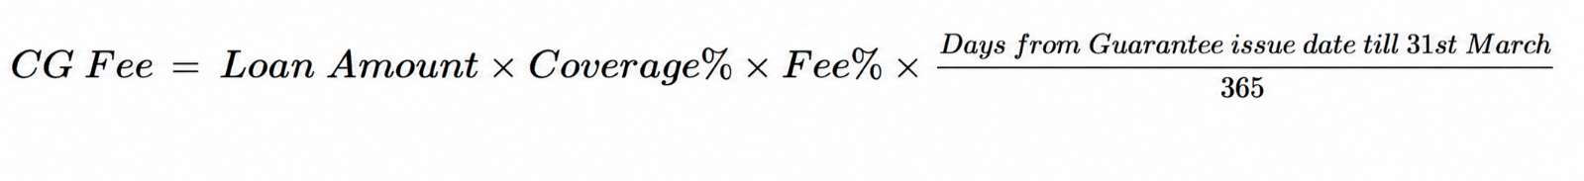
Step By Step Calculation:-
Step 1: Validate Score ≥ 60
Step 2: Fetch Coverage % & Fee % based on score
Step 3: Apply instrument cap on coverage
Step 4: Calculate tenure in days
Step 5: Apply CG Fee formula
Step 6: Round off final CG Fee (2 decimal places)

Scenario 1:- If the transaction date was of previous days i.e 20th April 2026 & Guarantee Issue date is 27th April 2026, then the fee will be calculated from the Guarantee Issue date till 31st March 2027 (FY 2026-2027).
Example Calculation

Input
- Loan Amount = ₹10,00,00,000 (₹10 Cr)
- Score = 72 → Coverage = 70%, Fee = 2.00%
- From 27 April 2026 to 31 March 2027 = 338 days

Calculation

CG Fee = ₹12, 96,438
Scenario 2:- If the guarantee end date you enter is before 31st March, the system will treat that as the final end date of the guarantee.
The CG fee will then be calculated only for the period from the Guarantee Issue Date up to that entered end date (not till 31st March).
Example Calculation

Input
- Loan Amount = ₹10,00,00,000 (₹10 Cr)
- Coverage = 70%
- Fee = 2.00%
- Guarantee Issue Date = 1 Dec 2025
- End Date = 15 Feb 2026 (before 31st March)
Step 1: Calculate Number of Days
- From 1 Dec 2025 → 15 Feb 2026 = 76 days
Step 2: Apply Formula

Step 3: Final Calculation
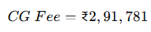

- For document type – RP (Risk Participation), the guarantee cover will be calculated and the guarantee will be issued without payment. In Update CG, termination date will be captured & on the basis of this CG fee demand will be raised.
- CG fee calculation will be system-driven & on pro-rata basis.
- For invoice generation, a single bill will be generated separately for New CG & Update CG, on batch basis that are received on daily basis. ( This will be executed through running the scheduler after 12 AM—this will generate the single estimate of invoice for New CG & Update CG )
- The aggregate fund from the Corpus application under the Dashboard CR shall be fetched for this scheme. The corpus limit shall be calculated as 10 times the aggregate fund available in the Corpus application.

3.1.3 Template of New CG for Management Certificate is attached below:



3.2 Update CG File
EXIM Bank sends an update request through API, following which the system validates the updated data, updates the CG record, recalculates the fee on a pro-rata basis and generates an updated invoice estimate.
Sr. No. | Field Name | Description | Type | Mandatory/Optional
1 | CGPAN | Unique No issued by NCGTC against each guarantee | Alphanumeric | Mandatory
2 | Name of Exporter/Beneficiary | Name of the entity | Alphanumeric | Pre-filled
3 | Importer Exporter Code (IEC) | Exporter's (Importer Exporter Code) | 10-digit Alphanumeric | Pre-filled
4 | Name of Importer/Applicant | Name of the entity | Alphanumeric | Pre-filled
5 | Beneficiary Bank (Partner Bank) | Name of the beneficiary bank (Partner Bank) | Alphanumeric | Pre-filled
6 | Document Number | Identifying number of instrument (LC,RP, IRU) | Alphanumeric | Pre-filled
7 | Udyam Registration Number | Udyam Registration Number of exporter | Alphanumeric | Pre-filled
8 | Unique Identification Number (UIN) | UIN issued on DGFT portal to exporter | Alphanumeric | Mandatory
9 | Transaction ID | Transaction ID issued by EXIM Bank of exporter | Alphanumeric | Pre-filled
10 | Existing Guarantee Cover | Existing guarantee coverage amount in Rs. | Amount in Rs. | Pre-filled
11 | Amendment Date | Date on which the amendment is sought | Date | Mandatory
12 | Limit enhanced/reduced | Select any one option | Enhanced/Reduced/No change | Mandatory
13 | Enhanced/reduced amount | Increase/decrease in the value of LC as per amendment | Amount in Rs. | Mandatory if enhanced/reduced
14 | Tenure extended/reduced | Increase/decrease in the validity of LC as per amendment | Increased/decreased/no change | Mandatory
15 | Extended/reduced tenure | In days | Number | Mandatory if enhanced/reduced
16 | Termination date for RP | Date on which RP is expected to be terminated | Date | Mandatory if instrument type entered at New CG is RP
17 | CG Fees | If enhanced limit/extended tenure | Amount in Rs. | Display

CG Fee Calculation for RP Cases (Update CG – Termination Based)
In Update CG, termination date will be captured & on the basis of this CG fee demand will be raised.
Example 1.
Input Details
- Loan Amount = ₹10,00,00,000 (₹10 Cr)
- Coverage = 70%
- Fee = 2.00%
- Guarantee Start Date = 1 Dec 2025
- Termination Date = 15 Mar 2026
- For FY 2025 - 26
Step 1: Calculate Number of Days
- From 1 Dec 2025 → 15 Mar 2026 = 105 days
Step 2: Apply Formula
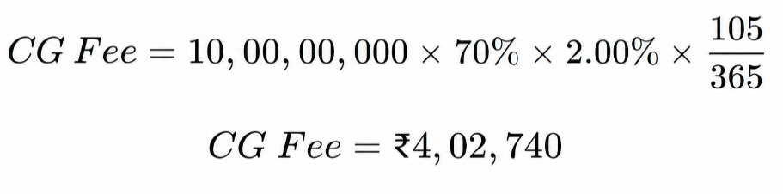
If terminated date of previous financial year falls in next FY, like Guarantee Start Date is 1st December 2025 & terminated date is 15th June, first part of guarantee fee will be calculated up to 31st March, i.e., from 1st December 2025 to 31st March 2026 (For FY 2025-2026)
Input Details
- Loan Amount = ₹10,00,00,000 (₹10 Cr)
- Coverage = 70%
- Fee = 2.00%
- Guarantee Start Date = 1 Dec 2025
- End date = 31st Mar 2026
- For FY 2025 - 26
Step 1: Calculate Number of Days
- From 1 Dec 2025 → 31 Mar 2026 = 121 days
Step 2: Apply Formula
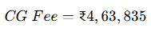
In case the termination date falls in the next financial year (e.g., 15th June), the second part of the CG fee will be calculated only for remaining period from 1st April to the termination date (15th June), considering the actual active period within that FY 2026-2027.

Then Apply Formula for Remaining Period in Next FY
Step 1: Consider Relevant Period (Next FY)
- From 1 April 2026 → 15 June 2026
Step 2: Calculate Number of Days
- April = 30 days
- May = 31 days
- June = 15 days
Total = 76 Days
Step 3: Apply Formula
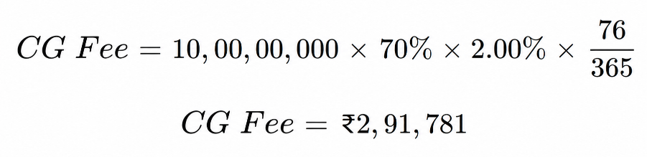
CG Fee Calculation – Pro-Rata (Update CG Scenarios)
1. Scenario: Tenure Extension

Step | Description | Calculation | Amount (₹)
1 | Initial Loan Amount | Given | 10,00,000
2 | Initial Tenure | Given | 12 months
3 | Fee % (based on score) | Given | 2.00%
4 | Initial Total CG Fee | 10,00,000 × 2% | 20,000
5 | Tenure Utilized | Given | 6 months
6 | Fee Earned (till update) | 20,000 × (6/12) | 10,000
7 | Revised Tenure | Given | 18 months
8 | Revised Total Fee | 10,00,000 × 2% × (18/12) | 30,000
9 | Additional Fee Payable | 30,000 – 10,000 | 20,000

2. Scenario: Amount Enhancement

Step | Description | Calculation | Amount (₹)
1 | Initial Loan Amount | Given | 10,00,000
2 | Enhanced Loan Amount | Given | 15,00,000
3 | Total Tenure | Given | 12 months
4 | Fee % | Given | 2.00%
5 | Tenure Utilized | Given | 6 months
6 | Fee (First 6 months – Old Amount) | 10,00,000 × 2% × (6/12) | 10,000
7 | Fee (Remaining 6 months – New Amount) | 15,00,000 × 2% × (6/12) | 15,000
8 | Revised Total Fee | 10,000 + 15,000 | 25,000
9 | Initial Fee Charged | Given | 20,000
10 | Additional Fee Payable | 25,000 – 20,000 | 5,000
3. Scenario: Amount Enhancement + Tenure Extension
Step | Description | Calculation | Amount (₹)
1 | Initial Loan Amount | Given | 10,00,000
2 | Enhanced Loan Amount | Given | 15,00,000
3 | Initial Tenure | Given | 12 months
4 | Revised Tenure | Given | 18 months
5 | Fee % | Given | 2.00%
6 | Tenure Utilized | Given | 6 months
7 | Fee (First 6 months) | 10,00,000 × 2% × (6/12) | 10,000
8 | Fee (Remaining 12 months) | 15,00,000 × 2% × (12/12) | 30,000
9 | Revised Total Fee | 10,000 + 30,000 | 40,000
10 | Initial Fee Charged | Given | 20,000
11 | Additional Fee Payable | 40,000 – 20,000 | 20,000

- CG Fee shall be calculated on a pro-rata basis considering tenure and amount.
- Any update in loan amount and/or tenure will trigger recalculation of CG Fee.

3.2.1 Template of Update CG for Management Certificate is attached below:



This scheme will be accessible to all EXIM users, followed by an NCGTC Creator and NCGTC Approver workflow, with the NCGTC Accountant having view-only access.

4. Report

Below reports required at NCGTC side & template format of report is attached below: -
1. Sanction Report



2. Update Report

For report access, an API will be provided to EXIM Bank, enabling them to fetch sanction data and updates. EXIM Bank will consume this API to retrieve the required report details and populate them in the prescribed template attached above.

3. Summarized Report
This Report should be visible at NCGTC creator & NCGTC approver side in below attached format.

